Tees Rowing Club
Trailer Towing Guidelines

December 2020
The purpose of this document is to provide basic safety guidelines to the drivers of vehicles towing the Tees Rowing Club (TRC) trailers.
All drivers are asked to read this entire document; sign the document on the last page and return it to the TRC Secretary.

TRAILER TOWING GUIDANCE
LEGAL REQUIREMENTS

Weights
Check weight and tow weights of towing vehicle. The unladen weight and max laden weight of trailer are displayed on the trailer. The usual guidance is that trailer laden weight should not exceed 85% of towing vehicle, however the trailer laden weight must not exceed the tow weight of the vehicle. Be careful not to overload the towing vehicle (with, for example, passengers.)
(Old trailers: Unladen weight of is 700kg, Max laden weight is 2000kg; Typical weight of 2x is 40kg, 4+ is 60kg and 8+ is 110kg.)
Rear Projection Behind The Trailer Board
If this is greater than 1m then it must be marked by a reflector or rag during daylight and a lamp at night. This marking must be visible from the side and rear. The maximum projection behind trailer board (rear) must not exceed 3m
Licence
For Drivers who hold Driving Licences issued after 1/1/97 the driver must take a further practical test so that they hold category B + E and/or D + E if the towing vehicle is a minibus with more than 8 seats.
Speed Limits
Motorway /dual carriageway 60 mph, other roads 50 mph. Vehicles towing trailers are not permitted on the outside lane of motorways with 3 or more lanes.
INSURANCE REQUIREMENTS
Drivers Insurance
The driver must ensure that their standard insurance is valid for trailer towing (usually at no extra cost).
TOWING ISSUES
Effects of Speed
Be aware of the need for extra breaking distance. If snaking starts, ease off the accelerator. Snaking may also start on downhill stretches.

Front and Rear Projection
Be cautious when manoeuvring at junctions, roundabouts, traffic lights and at regattas.
Trailer Wheels and Tyre Pressures
Ensure that tyres (including spare) are at the correct pressures (these are shown on the tyres) and that the tread is within the legal limit (1.6mm across the centre three quarters of the tyre and around the entire circumference)
Always check that the wheel nuts are tight (using light-medium force only) – DO NOT OVER TIGHTEN. You will need a suitable brace for this.
You may choose to carry a suitable jack and tools to change a punctured tyre or rely on your own breakdown cover.
Trailer Lights and Number Plate
Check lights function and correct number plate is displayed.
Load Security, Weight Distribution
The drivers should satisfy themselves that the boats are tied tightly and that the heavier boats are near the bottom. Ensure that the trailer nose weight is >50kg and is less than the max permitted for the towing vehicle. This limit is typically 50-75 kg for cars. With twin axle trailers, this can only be done on flat level ground, with the tow hitch at the same height as the car tow ball, in the loaded condition.

- The pages following this page show British Rowing’s “Guidance for the Transportation of Oar-Propelled Racing Boats”.
- Tees Rowing Club currently owns and operates 2 purpose-built De Graaf boat trailers – TRC1 and TRC2 and a newer lighter trailer.
- These trailers are to be towed by a person suitably qualified AND APPROVED BY THE TRC TRAILER CO-ORDINATOR ONLY.
- The current trailer co-ordinator is: Richard Olver 07717 305355 richard_olver@yahoo.co.uk.
- Please ensure that the handbrake is OFF when the trailer is being towed. And that the breakaway wire is secured.
- The telescopic jockey wheel must be retracted to its fullest extent and retained securely using the securing handle prior to the use of the trailer.
- The trailers are equipped with an extending light board and tailgate. Please return this to its fully-retracted position after the use of the trailer.
- The trailers are equipped with trailer brakes which operate automatically as the vehicle & trailer combination slows down.
- Please ensure that this automatic mechanism is functioning correctly and, if not, please report this immediately.
- Where the mudguards are made from plastic (as opposed to metal) please ensure that the mudguards are not stood on during boat loading/offloading.
- Please ensure that a trailer wheel is clamped when the trailer is parked and not in use.
- Security wheel clamp keys can be obtained from the trailer co-ordinator.
- The unladen weight of the trailer is approximately 1100kg.
- The following chart shows APPROXIMATE weights of Rowing boats (with riggers).
Single Scull (1x) | 16g
Double Scull (2x) | 30kg
Pair Without Coxswain (2-) | 30kg
Four Without Coxswain (4-) | 55kg
Four With Coxswain (4+) | 56kg
Quadruple Sculls (4x) | 57kg
Eight (8+) | 100kg

Please note: when calculating the GROSS weight of the trailer (unladen weight + weight of boats) PLEASE remember to include the weight of the oars and other equipment.
- If you discover a fault with the trailer please report it immediately (verbally and then by email) to the trailer co-ordinator.
- TRC’s policy is to have the trailers safety-checked in a vehicle workshop at regular intervals (depending on use) but not less than twice per annum.
- Rowing boat trailers are not currently subject to a statutory MOT.
- Securing straps (for securing the boats to the trailer) can be obtained from the trailer co-ordinator.
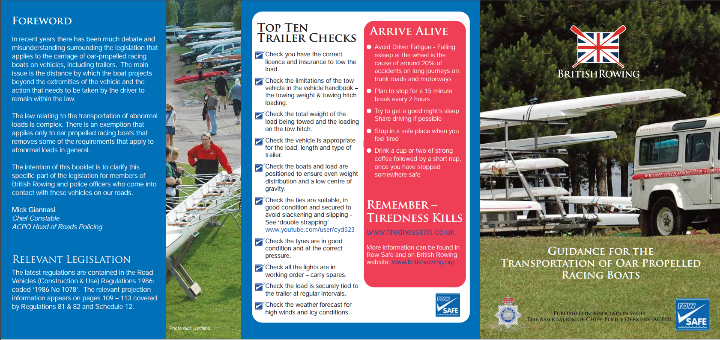

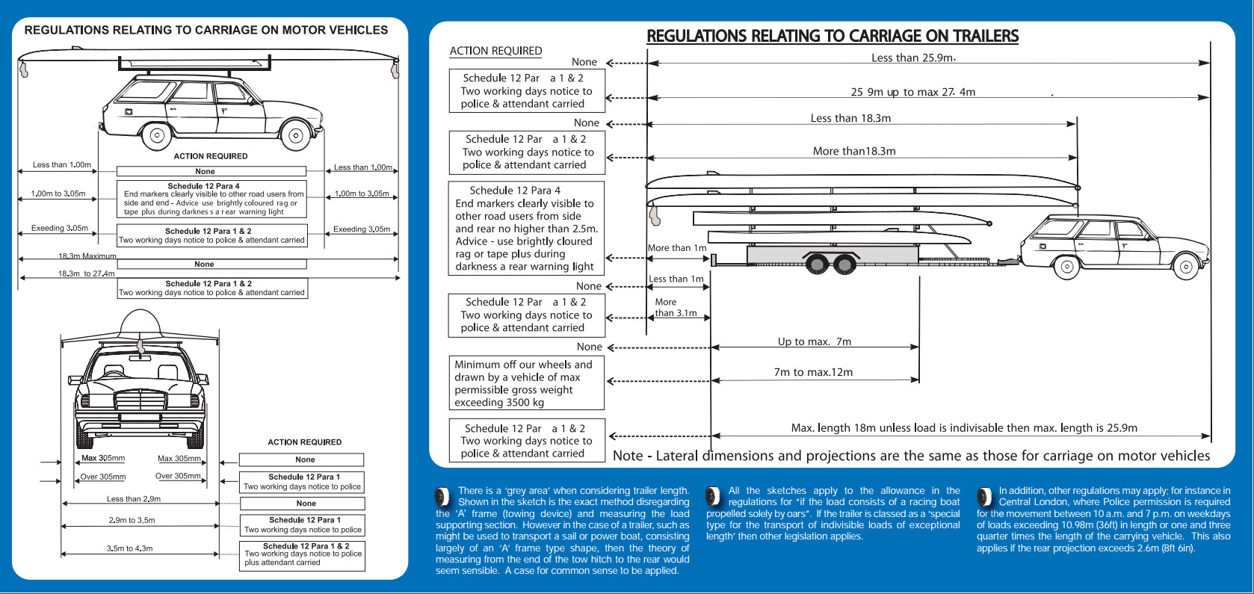

The information above and much more is freely available on the British Rowing Website, please take the time to read these very informative documents below.
Towing Guidance
Guidance for the transportation of oar-propelled racing boats.
Driving and Towing Limitations for Drivers
This flow chart explains the limitations for Category B drivers.
DVLA Towing Trailers Information – Licence Requirements
The licence requirements for towing trailers in Great Britain.
DVLA Minibus Information
A leaflet on the legal requirements.
Other Towing Resources
Government advice on towing accidents, the Caravan Club site and Ray Mallet’s guide to Rowing & Trailers.

I confirm that I have read and understand the Tees Rowing Club Trailer Towing Guidelines (which incorporate British Rowing’s “Guidance for the Transportation of Oar-Propelled Racing Boats”) and I agree to adhere to them.

Signed: _____________________________________________________

Date:-------------------------------------------------------------------------------------------------

