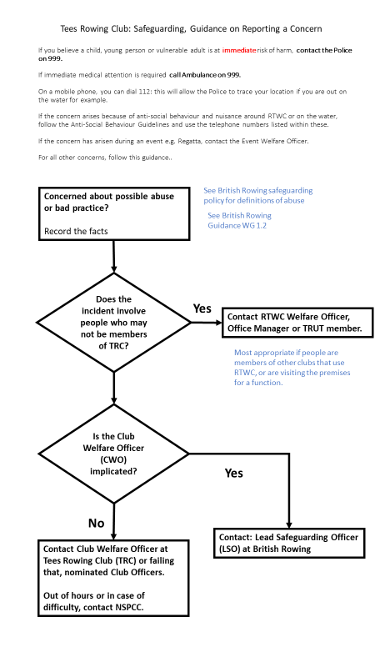
Although most cases of abuse take place within the family setting, it can and does occur in rowing.
- It is essential that all allegations are taken seriously and appropriate action is taken.
- It is not your responsibility to decide if a child or vulnerable adult is being abused.
- It is your responsibility to report your concerns to the appropriate agencies.
- Not acting is not an option.
If you are not sure and want to discuss something please contact the Club Welfare Officer, British Rowing’s Lead Safeguarding Officer or a statutory agency for advice.
Remember:
- The welfare of the child or vulnerable adult is paramount
- being vigilant helps to protect such people
- everyone has a duty of care to report any concerns they have immediately
- a good reporting structure ensures that concerns are dealt with fairly.
See British Rowing Safeguarding Policy for further information as well as their following guidance notes:
- WG 1.2 Report form for recording concerns and referrals
- WG 1.8 Advice and support for individuals receiving a concern or allegation
- WG 1.9 Advice and support for those who have reported concerns
- WG 1.11 Flowcharts for referral procedure within rowing
- WG 1.12 Flowchart for referral procedure outside rowing
- WG 1.14 Vulnerable Adults: How to record concerns of abuse
- WG 1.15 Dealing with allegations of bullying of Vulnerable Adults
Revision date of this document: August 2019.

