THE BASIC SCULLING STROKE

A sound sculling technique is not achieved overnight and requires hours of physical and mental attention. Many of us taking up sculling at a more mature age need to be realistic at what is possible and not become disillusioned at not being able to match the achievements of the younger athletes we see making it appear so effortless. An awareness and understanding of the basic sculling stroke and a willingness to get it right will go a long way in you being able to produce an effective stroke.

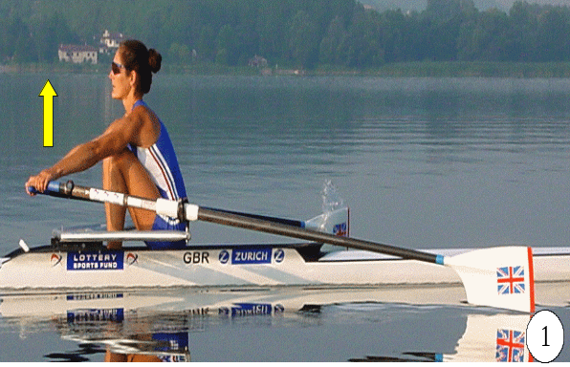 | This is the start phase of the stroke when the blades are placed in the water (called THE CATCH) and when the boat is driven forwards using the large muscle groups in the legs and body.  - The shins are vertical, the back straight and leaning forward with the body closed up on the thighs.  - All that is needed is for the hands to lift a little more in the direction of the arrow and the blades will be fully locked in the water.
Common Errors at This Point:

- The seat begins to move backwards faster than the shoulders. This fault is known as “bum shoving” and it causes the powerful leg drive to be weakened considerably.

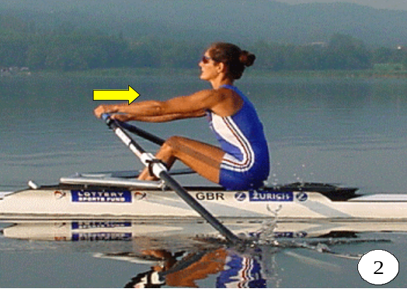 | It is a mistake to think that rowing is pulling with the arms, but many beginners do this.  - The legs should be doing most of the work here with the arms relaxed and the back still straight and leaning forward.  - The hands follow the path of the arrow parallel to the boat. The feeling should be that of hanging off the blade handles.
Common Errors at This Point:

- Arms pulling over the knees into an arc causing the blades to plunge too deep.

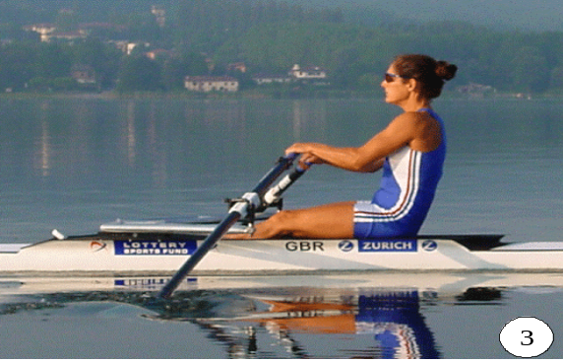 | At this point the sculler is nearing the end of the drive phase and the body is about to stop swinging back whilst the arms are now being used to maintain the momentum of the blade handles.
Common Errors at This Point:

- The blade handle is pulled down (instead of along) causing the blade to lift from the water before the end of the stroke. This is called “washing out”.

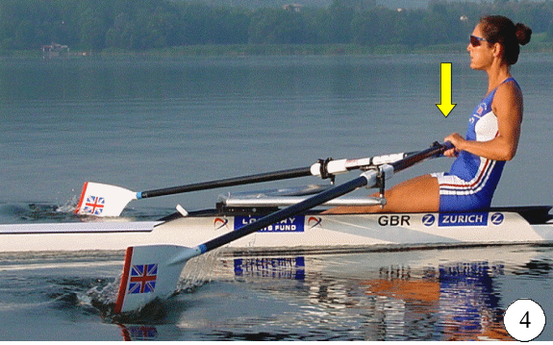 | At this position the hands make a small tap downwards to lift the blades clear of the water.  - The legs are flat.  - The back is straight, but leaning slightly back so that the abdominal muscles feel a slight pull.  - The blade handles just brush the body when the spoon end is flat on the water.
Common Errors at This Point:

- The sculler sits too upright and the elbows droop down – the effect is to shorten the stroke.
- The sculler leans too far back – which delays the recovery.

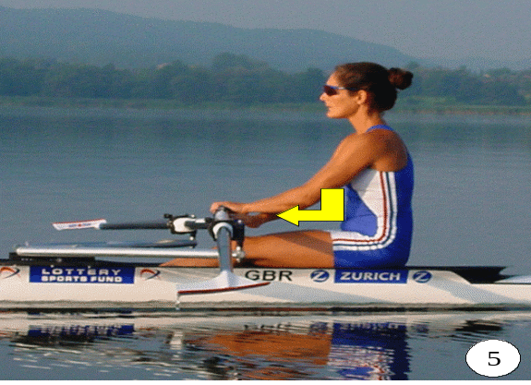 | At the beginning of the recovery phase the hands move down and away, following the trajectory of the arrow.  - The arms move away from the body but the seat has not yet begun to move and the knees are still held down.  - Arms, body and shoulders are relaxed.  - Body then rocks over pelvis, knees lift allowing seat to move.
Common Errors at This Point:

- The knees lift and get in the way of the legs.
- The hands move too slowly.

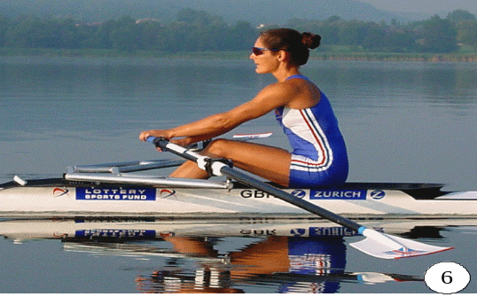 | The body is relaxed, the blades are clear of the water and the sculler is mentally preparing to square the blades.
Common Errors at This Point:

- The hands are higher or lower than the point shown.
- The body is not leaning forward at the angle shown.
- The sculler does not slow momentum before taking the catch.
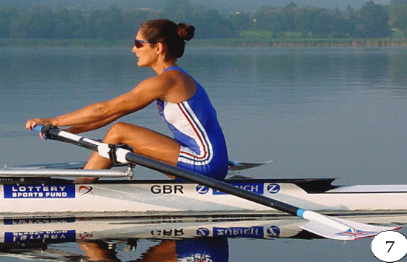 | Common Errors at This Point:  - The body is too upright and the arms are not straight.  - The sculler moves up the slide too quickly.

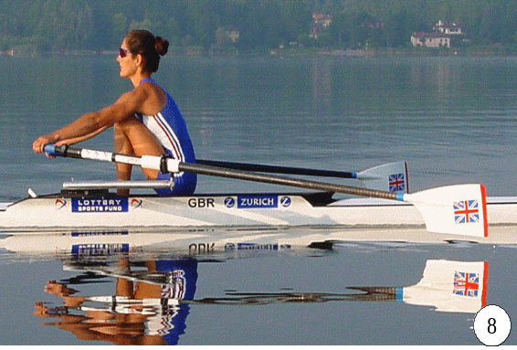 | The body at this stage is in the catch position still moving forward until the shins are vertical.  The sequence begins again.  - The blades should be square and just above the water.  - The head should be looking forward.  - The arms should be straight but relaxed.
Common Errors at This Point:

- The sculler does not reach forward to maximize the length of stroke.
- The body collapses over the knees.
- The shins are not vertical.

